Suraj Raut — WP3 Individual Contribution & Progress Report
PRT661 – Data Science Practice | Dan6 Theme 2 | Modelling, Forecasting and Verification
Student | ID | WP3 role | Workstream
Suraj Raut | S391201 | Data Engineering Lead | XGBoost A/B · recursive engine · lag provenance · frozen four-month forecast

Evidence note This document is aligned to the verified 14 September Stage 3 run. Contribution descriptions preserve the role boundaries in the existing WP3 documents and describe shared integration as team work rather than assigning the final pipeline to one person.

1. Allocated WP3 responsibility
Suraj’s Stage 3 responsibility is the long-horizon execution layer: implement the XGBoost A/B challenger family, maintain the recursive time-series state used after forecast origin, record whether lag inputs come from actual history or earlier predictions, and construct the frozen month-start four-month forecast that later verification must score without alteration.
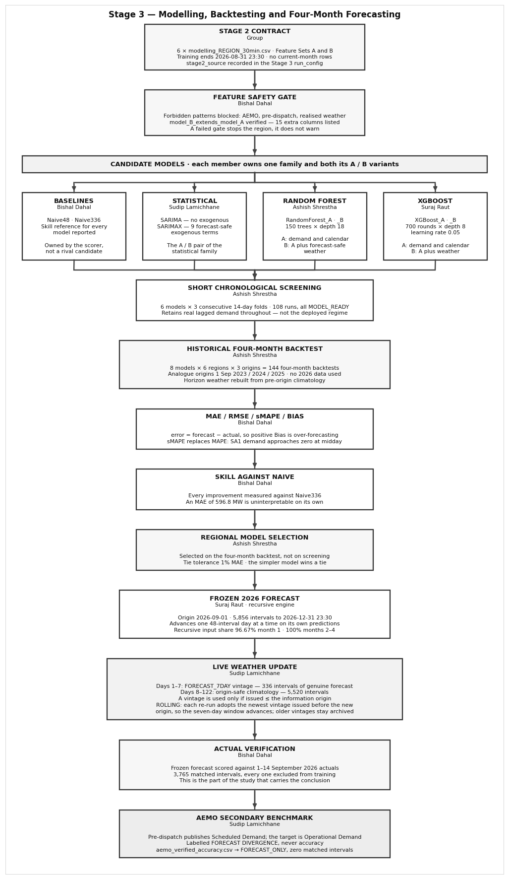
Figure 1. Suraj-owned blocks: XGBoost A/B, recursive time-series mechanics and the frozen 2026 forecast.

2. Why XGBoost was included
XGBoost provides a boosted-tree alternative to Random Forest. Both can capture nonlinear demand patterns, but they learn differently: Random Forest averages many independently sampled trees, while XGBoost sequentially adds trees to correct prior residuals. A/B variants use the same Stage 2 feature contracts as Random Forest so differences reflect the algorithm rather than different input information.
Implemented full-mode configuration 700 boosting rounds, maximum depth 8, learning rate 0.05, 0.8 row subsampling, 0.8 column subsampling, L1/L2 regularisation and histogram tree construction. The random state is fixed for reproducibility.

Region | Model | MAE | RMSE | sMAPE | Bias
NSW1 | XGBoost_A | 661.5 | 939.9 | 9.87% | +146.0
NSW1 | XGBoost_B | 629.7 | 958.2 | 9.54% | -159.9
QLD1 | XGBoost_A | 463.4 | 649.6 | 8.00% | -134.4
QLD1 | XGBoost_B | 471.7 | 670.0 | 8.16% | -238.0
SA1 | XGBoost_A | 218.2 | 299.2 | 27.43% | +79.9
SA1 | XGBoost_B | 198.5 | 292.1 | 26.21% | +27.8
TAS1 | XGBoost_A | 76.4 | 96.9 | 7.37% | +43.2
TAS1 | XGBoost_B | 73.5 | 92.9 | 7.12% | +36.3
VIC1 | XGBoost_A | 482.6 | 676.4 | 11.91% | +45.6
VIC1 | XGBoost_B | 483.1 | 691.6 | 12.01% | +3.6
WA | XGBoost_A | 273.5 | 363.8 | 15.26% | -38.4
WA | XGBoost_B | 220.3 | 322.5 | 12.47% | -91.6

XGBoost is competitive but not selected overall in the final six-region result. TAS1 Model B family selection uses XGBoost_B when the comparison is restricted to weather-enhanced tree models, showing that the family contributes useful challenger evidence even though Random Forest is the final overall winner.

3. Recursive time-series engine
The four-month horizon cannot rely on a one-step backtest shortcut. At the forecast origin, lag_48, lag_96 and lag_336 initially reference genuine history. As time advances, those references eventually land inside the forecast horizon and therefore must use earlier model predictions. Suraj’s recursion engine advances in 48-interval (one-day) blocks, recalculates demand-derived features from the evolving history/prediction array, and records provenance for every required lag.
Lag provenance label | Meaning for a forecast row
ACTUAL_HISTORY | The referenced lag falls before the forecast origin and comes from observed training history.
RECURSIVE_FORECAST | The lag falls at or after the forecast origin and therefore comes from an earlier model prediction.
MISSING | No valid lag reference exists in the available timeline.

This provenance prevents a common long-horizon error: filling a future lag with the actual value that happened later. The final leakage suite reports 78/78 PASS, including the recursive-lag provenance rule.

4. Frozen month-start four-month forecast
The frozen forecast is issued from 1 September 2026 using training data that ends at 31 August 2026 23:30. It contains 5,856 half-hour intervals per region through 31 December 2026 23:30. The forecast is immutable for verification: later September actuals can be compared with it but cannot rewrite it.
Month | Recursive-input share | Interpretation
September 2026 | 96.67% | Only the earliest part of the month can still reach pre-origin actual lags.
October 2026 | 100% | All required demand-lag references depend on forecasted values.
November 2026 | 100% | Fully recursive demand-history context.
December 2026 | 100% | Fully recursive demand-history context; uncertainty is expected to be highest.

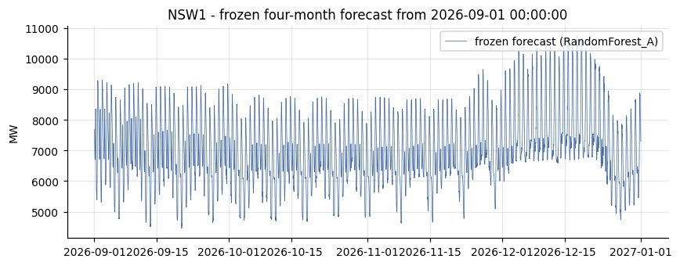
Figure 2. Example frozen four-month NSW1 forecast generated from the month-start information boundary. The forecast is stored as a vintage for later verification.

5. Horizon reusability
The horizon is not hard-coded to September–December. The December crossover self-test proves that the same logic resolves December 2026 through March 2027 and produces matching historical December analogue origins. All 5/5 horizon/reusability tests pass. This is important because the final project is intended to roll forward monthly rather than stop after one demonstration period.

6. Team collaboration and handoff
- Bishal supplies the baseline/metric framework that later scores XGBoost and the frozen forecast.
- Sudip’s weather-vintage policy determines the known-future weather values available to XGBoost_B and later Model B refreshes.
- Ashish’s screening/backtest/selection orchestrator treats XGBoost as a full candidate under the same historical windows as Random Forest.
- The group freezes the cutoff/horizon contract before recursion runs so no member can move the forecast origin to improve a result.

7. Code and evidence artefacts
Artefact | Contribution evidence
04_Suraj_Raut_XGBoost_Recursive_FourMonth_Forecast.py | XGBoost configuration, rolling four-month horizon, lag provenance, recursive feature rebuilding and frozen forecast framing.
validation/four_month_backtest_scores.csv | XGBoost A/B results over three historical analogue origins.
validation/leakage_tests.csv | Recursive-lag and previous-month-cutoff checks.
forecasts/frozen/ | Immutable region-level four-month forecast vintages.
forecasts/forecast_monthly_summary.csv | Monthly forecast means/peaks, energy and recursive-input share.

8. Professional reflection
The difficult part of long-horizon forecasting is not producing thousands of numbers; it is preserving the information boundary after the first few days. Once every important lag points inside the forecast horizon, the model is learning from its own earlier predictions and errors can accumulate. Making that recursion explicit in code and in the output provenance gives the team a realistic basis for future improvements such as uncertainty intervals, direct multi-horizon models or scheduled rolling refreshes.

